RADIATION

CONTROLLED AREA
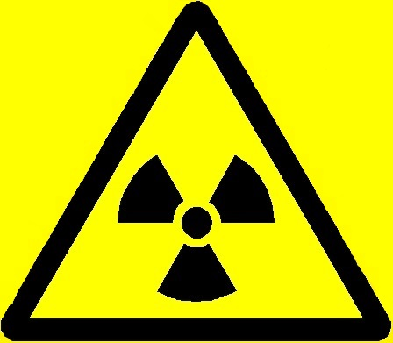

RISK OF X RAYS

NO ENTRY EXCEPT AUTHORISED PERSONS WHEN WARNING LIGHT IS ON

DEPARTMENT | :
RADIATION PROTECTION SUPERVISOR | :
AREA RADIATION SUPERVISOR | :
ROOM NUMBER | :
TYPE OF RADIATION SOURCE | :
DESCRIPTION | : | Controlled Area due to the potential presence of x radiation from an x-ray set. The Controlled Area only exists whilst the x-ray set is generating radiation. This is indicated by the warning light accompanying this notice.

ACCESS WHILST THE WARNING LIGHT IS ON IS RESTRICTED TO THE AUTHORISED RADIATION WORKERS LISTED ON THE ACCOMPANYING NOTICE. ANY OTHER PERSON WHO REQUIRES ACCESS MUST HAVE THE PERMISSION OF THE RADIATION PROTECTION SUPERVISOR.

Date of Issue:

