RADIATION

SUPERVISED AREA
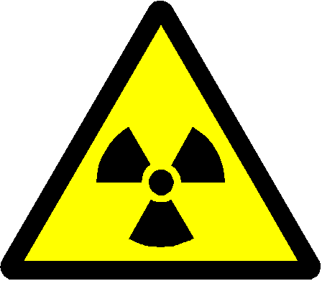

RISK OF RADIATION

NO ENTRY EXCEPT AUTHORISED PERSONS

DEPARTMENT | :
RADIATION PROTECTION SUPERVISOR | :
AREA RADIATION SUPERVISOR | :
ROOM NUMBER | :
TYPE OF RADIATION SOURCE | :
DESCRIPTION OF SOURCE(S) OF IONISING RADIATION | :

THE PERSONS AUTHORISED TO WORK WITH THE RADIATION SOURCE(S) IS/ARE LISTED ON THE ACCOMPANYING NOTICE.

Date of Issue:

