RADIATION

CONTROLLED AREA
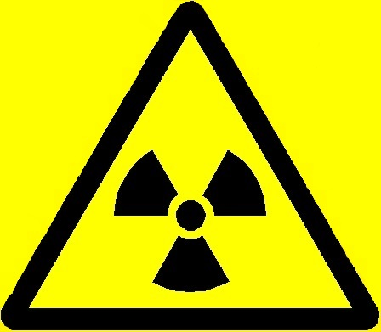

RISK OF RADIATION

NO ENTRY EXCEPT AUTHORISED PERSONS

DEPARTMENT | :
RADIATION PROTECTION SUPERVISOR | :
AREA RADIATION SUPERVISOR | :
ROOM NUMBER | :
TYPE OF RADIATION SOURCE | :
DESCRIPTION OF SOURCE(S) OF IONISING RADIATION | :

ACCESS IS RESTRICTED TO THE AUTHORISED RADIATION WORKERS LISTED ON THE ACCOMPANYING NOTICE. ANY OTHER PERSON WHO REQUIRES ACCESS MUST HAVE THE PERMISSION OF THE RADIATION PROTECTION SUPERVISOR.

Date of Issue:

