RADIATION

SUPERVISED AREA
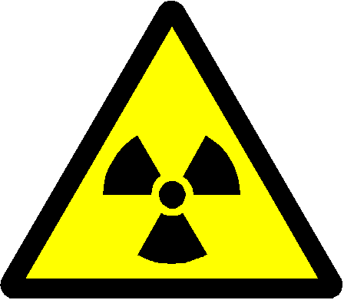

RISK OF RADIATION AND CONTAMINATION

NO ENTRY EXCEPT AUTHORISED PERSONS

DEPARTMENT | :
RADIATION PROTECTION SUPERVISOR | :
AREA RADIATION SUPERVISOR | :
ROOM NUMBER | :
TYPE OF RADIATION SOURCE | : | Unsealed Radioactive Material

MAXIMUM TYPICAL ACTIVITIES IN USE & IN STOCK
Isotope | In Use (MBq) | In Stock (MBq)

THE PERSONS AUTHORISED TO WORK WITH THIS RADIOACTIVE MATERIAL ARE LISTED ON THE ACCOMPANYING NOTICE.

Date of Issue:

