CoSHH Risk Assessment summary
Assessment Title
Assessment Reference
School / Management Unit |  | Location(s) of activity

Process Summary / Reaction Scheme

Reaction conditions (e.g. heat, vacuum, cooling, pressure):
Name of Substance  (Include all substances used or produced during this activity) | Quantity  (mmol) | Physical Form | GHS Hazard Classification (mark all that apply)
 | Quantity  (mmol) | Physical Form | 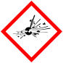Explosive | 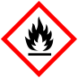Flammable | 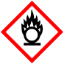Oxidiser | Comp. Gas | Harmful | 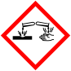Corrosive | 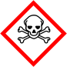Toxic | Health | 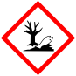Environment

Special hazards
Sensitising Chemical | Yes / No
Carcinogen / Mutagen | Yes / No
Teratogen / Harmful to unborn child | Yes / No
Pyrophoric substance | Yes / No
Explosive Atmosphere | Yes / No
Biohazard | Yes / No
Radiation | Yes / No
Other (specify) | Yes / No

Personal Protective Equipment required
  Gloves |  |   Lab Coat |  |   Safety Glasses
  Dust Mask |  |   Face Shield |  |   Other (Specify)

Control Measures (include any standard protocols used, relevant purification and quenching procedures)

Waste Disposal

Emergency Procedures / First Aid Requirements

Assessed by |  | Date
Checked and approved by |  | Date

Document management

Document version
Version number | Summary of change | Date and by whom
2.0 | Complete refresh after consultation | 17/09/26 C Harrison

Alt format
If you require this document in an alternative format please contact The Health, Safety and Wellbeing Department on health.safety@ed.ac.uk or call (0131) 651 4255

