CoSHH Risk Assessment (Chemical)
Assessment Title
Assessment Reference
School / Management Unit
Location(s) of activity
Safety Manager

Details of Hazardous Substances
Name of Substance  (Include all substances used or produced during this activity) | Quantity | Physical Form | GHS Hazard Classification (mark all that apply)
 | Quantity | Physical Form | 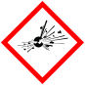Explosive | 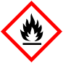Flammable | 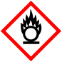Oxidiser | 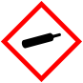Comp. Gas | Harmful | 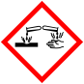Corrosive | 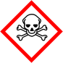Toxic | 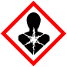Health | 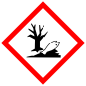Environment

Special Hazards (*separate risk assessment may be required)
Carcinogenic Substance | Details: | Sensitising Chemical | Details: |   Teratogen / may harm unborn child | Details:
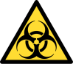  Biological Material* | Details: | 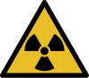  Radioactive Substances* | Details: | 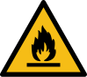  Explosive Atmosphere* | Details:
Further details / other special hazards:

Details of potential exposure to hazardous substances
Substance(s) | Potential Exposure Route (mark all that apply) |  |  |  |  | WEL
Substance(s) | Inhalation | Ingestion | Skin | Eye | Injection | 8h TWA | 15min STEL

Description of Activity
Description of activity (or refer to standard operating procedures)

Person(s) at risk
Person(s) at risk

Summary of control measures
Risk Rating  (before workplace control measures applied) | High |  | Medium |  | Low
Procedural Controls
(e.g. lone working, hygiene)
Engineering Controls
(e.g. use of fume cupboard)
PPE Requirements  (please give details)  **Face fit testing required |   Dust Mask** |  |  |   Gloves (specify type)
 |   Respirator** |  |  |   Footwear
 |   Eye Protection |  |  |   Protective Clothing
 |   Face Shield |  |  |   Other (Specify type)
Instruction and training
Supervision required?
Other safety precautions?
(e.g. specialist first aid)
Risk Rating  (after workplace control measures applied) | High |  | Medium |  | Low

Person(s) at Risk
Waste disposal procedure
Emergency procedures
Air monitoring required?
Health surveillance required
(please give details)
Medical surveillance required
(please give details)
Supporting risk assessments  (please attach where relevant) | Biological | DSEAR | Radiation

Assessment Verification
Assessed by |  | Date
Checked and approved by |  | Date
Date of next review

Document management

Document version
Version number | Summary of change | Date and by whom
2.0 | Complete refresh after consultation | 17/09/26 C Harrison

Alt format
If you require this document in an alternative format please contact The Health, Safety and Wellbeing Department on health.safety@ed.ac.uk or call (0131) 651 4255

