
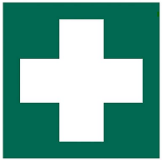
THE UNIVERSITY of EDINBURGH

FIRST AID

BUILDING:

 | NEAREST FIRST AIDERS
 | Name | Location

NEAREST FIRST AID KIT LOCATION:

DEFIBRILLATOR LOCATIONS:

Defibrillator Campus Map | Health and Safety Department
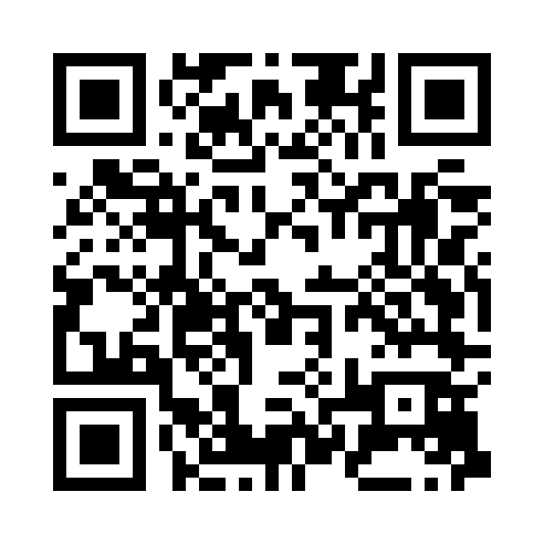

REPORT AN ACCIDENT, INCIDENT OR NEAR MISS:

Accident/Incident Reporting | Health and Safety Department
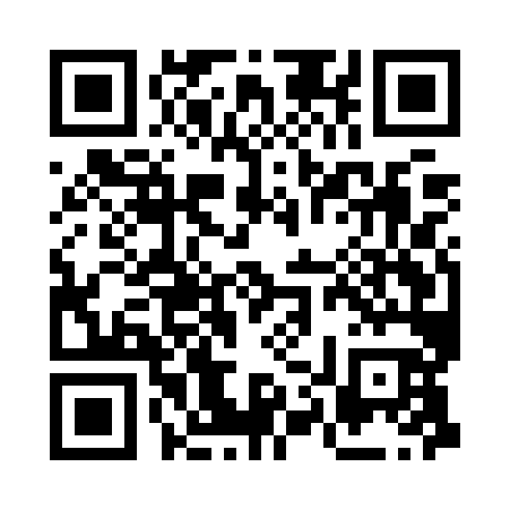

Please report changes to Date:

