Microscope Workbench Checklist


Introduction
Looking through a microscope for extended periods is not what we were designed for. It requires holding our bodies in an unnaturally rigid position. An ergonomically designed microscope would have eyepieces at about 90° from vertical. It is important to adopt a correct, ergonomic working posture. This means fitting the workstation to the worker, not vice versa. It is also important to take regular breaks.
Ideally, the microscope should be on a bench which is adjustable for height: first, the seating position is adjusted (steps 2-8 below) followed by the bench height and subsequent steps (11-22 below). The following is based on a fixed work bench. See Fig. 1.
Before entering ‘No’ to the following questions, attempt to rectify the problem.
 |  | Yes |  | No
1. | Have you been show how to use the microscope, including how to align the optical path to optimise performance? |  | If no, seek this training before continuing - other-wise, poor results and eye strain may ensue.
2. | Are you sitting back in the chair, rather than perching on it? |  | If no, sit back into the chair.
3. | Is the height of the chair adjusted so that your feet are resting comfortably, flat on the floor? |  | If no, adjust the chair height appropriately.
4. | Is there an even pressure along the backs of the thighs? |  | If no, check if the seat platform can be tilted appropriately for comfort. If not, consider readjusting the height slightly.
5. | Does the chair support your back in an upright position? Ideally, it should support to beyond the level of the shoulder blades. |  | If no, adjust chair back appropriately.
6. | Does the chair back give support in the lumbar region? |  | If no, check the chair’s back adjustment again, possibly adjusting the tilt control.
7. | Are you now sitting with your back upright? Ask a colleague to comment. |  | If no, repeat steps 2-6 above.
8. | Are the microscope eye-pieces in line with, or extending over, the front edge of the bench? |  | If no, move the microscope towards you appropriately (caution - you may need skilled assistance)
9. | Is the vertical position of the eye-pieces a little high for comfort, so that your head is upright? Initially, this will feel unnatural. |  | If no, raise the microscope vertically to a suitable height at which you are forced to sit upright. This can be done with layers of plywood etc.
10. | Can you see at all into the eye-pieces of the microscope? |  | If no, raise the chair height appropriately and obtain a suitable footrest.
11. | Are you gazing slightly downwards into the eye-pieces, as opposed to tilting your head and ‘looking straight-ahead’ into them? |  | If no, you are not sitting upright enough. The back should be ‘vertical’ and the neck and head upright. Holding the head tilted for long periods will induce neck and shoulder-ache. Repeat steps 2-10.
12. | Is the leg-well clear of clutter so that your legs and feet are not impeded when sitting at the bench? |  | If no, clear the clutter.
13. | Are your thighs clear of the under-surface of the bench? |  | If no, the bench is unsuitable for microscopy work. Have it modified or seek another site for the microscope.
14. | When operating the focus and stage controls, are your forearms resting on something, either the bench or microscope arm rests? |  | Holding the arms off the bench for long periods will induce static loading problems. The most comfortable position for the hands is as for when shaking hands
15. | Are the eyepieces set correctly for your inter-pupillary distance? |  | If no, set this distance properly - the oculars should move towards or away from each other. This reduces eye-strain.
16. | Are the eyepieces parfocal? |  | If no, adjust them individually so that the image is sharp in each. This reduces eye-strain.
17. | Are the eyepieces clean, for both optical and hygiene reasons? |  | If no, ensure that they are cleaned. Be aware that communicable eye diseases such as conjunctivitis can be transmitted by contact.
18. | Before you begin microscope work for the first time, are you free from pre-existing visual problems? |  | If no, you should see an optician in case you have astigmatism, fusion insufficiency (poor eye co-ordination) or simple long/short sight. Microscopy work may make these problems more obvious.
19. | Are your surroundings free from glare and reflections? |  | If no, try to remove light sources from the visual field by re-positioning the workstation, removing highly reflective surfaces, using blinds, curtains or other screens.
20. | Is the image in the microscope free from glare and reflection? |  | If no, adjust the internal lighting so that there is not an uncomfortably high level of light or contrast. This may be done by regulating the transformer or by using appropriate filters.
21. | Are you satisfied with other environmental factors, such as temperature, humidity, draughts, ventilation, ambient lighting? |  | If no, try to sort problems locally yourself or discuss them with line management or local safety advisor.
22. | Will you be focusing your eyes to distant vision periodically, e.g. through a window? |  | If no, you should take regular breaks from the work and look at something distant. This is prevent headaches/eye strain
23. | Are you/will you be taking regular breaks from the microscope, e.g. two or three minutes every half-hour, or rotating jobs? |  | If no, this needs urgent consideration. Breaks are necessary to prevent RSI (Repetitive Strain Injury), WRULD (Work-Related Upper Limb Disorders) or CTD (Cumulative Trauma Diseases). Discuss it with your manager and local safety advisor.
24. | When taking breaks from the microscope, will you be doing stretching exercises? |  | If no, you should do exercises to relieve the static loading fatigue/stress on the body. This applies equally to computer users. See exercises at http://www.docs.csg.ed.ac.uk/Safety/health/keying_comfortably_exercises.pdf

Fig. 1. Workstation set-up for microscopy
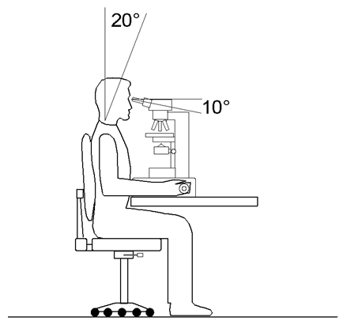

Note:
- Ocular level with eyes, raise bench or microscope to suit
- Oculars over front edge of bench, move microscope to suit
- Upright posture with major joints at near-right angles
- Ergonomic chair adjusted to support back and thighs
- Fore-arms supported, not under long period of static load
- Wrists straight, hands in ‘shake-hands’ position
- Feet comfortably supported by floor or footrest

