Sustainability Test Tool Guide
The Sustainability Test Tool is a tool that considers the sustainability of a purchase in the procurement department. It can be used with Sustainable Public Procurement Prioritisation Tool or on its own.
It has a set of questions that asks about how a specific purchase in the Procurement can be made more sustainable based on sustainable procurement guidance released by the government and also the University’s strategies. It then records the set of actions that have been agreed to be done during the different stages of the purchase. As the test tool is an interactive tool it is strongly recommended that when filling in the tool with a UIG that a room with PC and screen available.
How to fill in the Sustainability Test Tool
(including copying and pasting results from the Prioritisation Tool (SPPPt))
How to | Screenshots | Notes
- Download the Sustainability Test Tool Golden Copy from the Procurement website https://www.ed.ac.uk/procurement/sustainableprocurement/procurement-prioritisation | 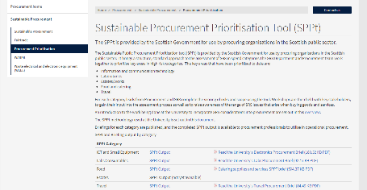 | When you’ve downloaded and opened the Test Tool, click enable content. A pop-up box asking you to sign in will also appear but just close that. A pop-up message saying ‘We can’t update some of the links in your workbook right now’ will appear too, but just click on continue. Click on ‘Yes’ when asked ‘Do you want to make this file a Trusted Document’.
- On the Procurement website  https://www.ed.ac.uk/procurement/sustainableprocurement/procurement-prioritisation  Find the type of category /commodity of the procurement you are doing and download the corresponding Sustainable Procurement Prioritisation Tool (SPPt) Output from the following categories and open the excel file:  - ICT and Small Equipment  - Labs Consumables  - Food  - Travel  - Estates | 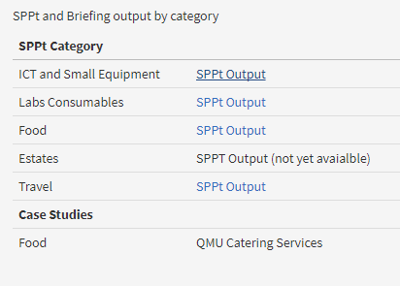 | Click Enable Content
- Go back to the Test Tool excel, and save it to your project folder on the K: drive. Open the “Admin & Import” tab and start by completing number 1. ADMIN | 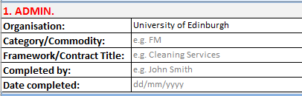 | Rows 2-6 are also summary guidance.
- Still in the Admin & Import tab, fill in 2. INITIAL QUESTIONS. Yes/No questions. | 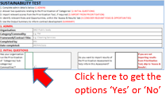  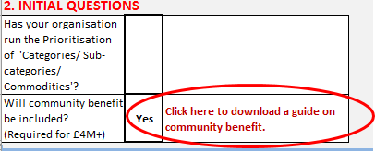 | The questions regarding “Community Benefit” and “Fair Work Practice” will automatically flag relevant categories to “Yes” in the “Assess & Results” and “OUTPUT SUMMARY” tabs.  There is a headline guide available regarding Community Benefits by clicking the link in C16.
- Choose the right category and sub category of the purchase from the drop down list in the Sustainability Tool. If your project category does not have an SPPT, please select ‘Not_covered_in_SPPt’ in cell C22, and ‘Not Covered’ in cell E22. | 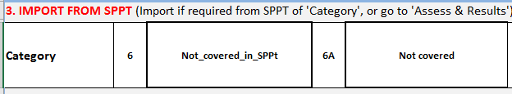 | This will not work if the relevant category output spreadsheet is not opened.
- The area inside the red rectangle will be automatically completed. | c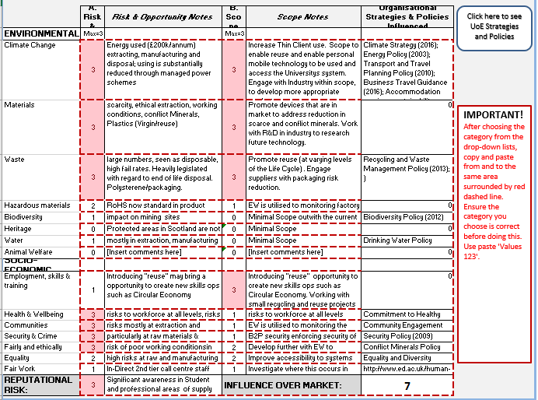
- Once the answers are pulled out, copy (CTRL+C) from & paste values (CTRL+V then select 123) onto the same area surrounded by red dashed line. | 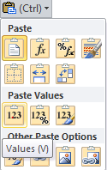 | After this stage, the tool will work without the need of having the SPPt output file opened. You can also expand the rows between row 26 and row 41 so that all text is showing.
- On the Sustainability Test Tool, click on the ‘Assess & Results’ tab and answer the questions for each category with drop down Yes/No; using the risk and scope scores as guidance. | 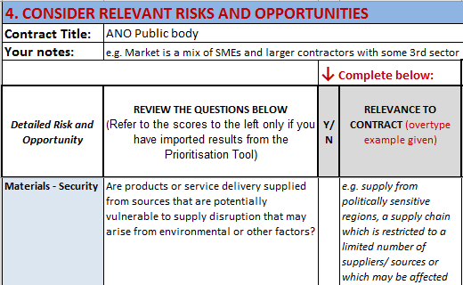  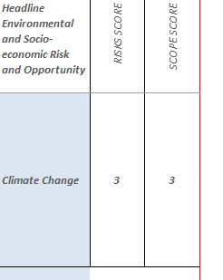 | This should be done in discussion with user intelligence group referring also to the captured SPPt output in the Admin and Import tab.  << BEST PRACTICE – You may not need to cover every aspect, but ensure you address the categories which have the highest Risk, Influence and Scope scores.
- Fill in the next column on how the category is relevant to the contract (overtype on the examples given)

- Write the actions you will take during each stage to make the purchase more sustainable (overtyping examples given). Check on the relevant section of the corresponding guidance by clicking on the ‘Link to section’ for ideas. | 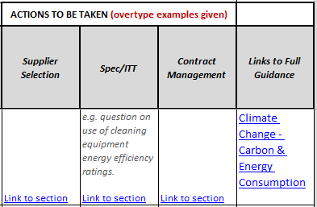 | The amount of details entered should be proportional to the value of the procurement. The ‘Link to section’ will take you to the relevant guidance tab and the relevant procurement stage applicable.  The guidance will be regularly updated but where there is no ‘Link to section’ the guidance is yet to be created.
- For strategy report, open the ‘Strategy Report’ tab, filter Yeses only. Overwrite any relevant text (in green). Once done copy the table, and paste it into the Strategy Report. See placeholder in Strategy Report template.

- On the Sustainability Test Tool, click on the ‘OUTPUT SUMMARY’ tab. The answers in this tab are taken from your answers in the Assess & Results tab. You can filter the answers on column G so that the whole sheet shows only the answers that are relevant to the purchase (‘Yes’ on column D) | 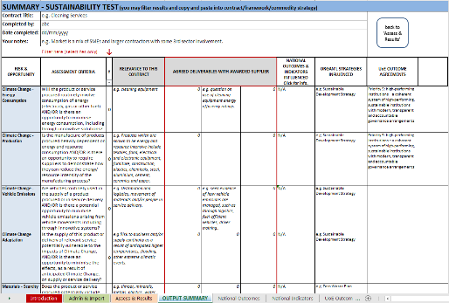
- Fill in the cells in red borders in the “Measures included in Procurement Document” column by overtyping the previous answers with actions agreed with the awarded supplier during the contract | 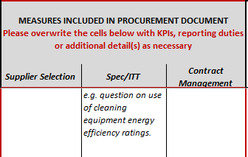
- Open the ‘Recomm Report’ tab, filter Yeses only, copy the part in the red rectangle, and paste them into the report.

